

MANAGER & FACILLITY REPORT 2022 JUNE

- I’ve signed a contract with Wetland Resources Inc. to finish the remaining 8 years of monitoring and reporting
- Turkey vultures are a big problem at the airport currently.
- We had a bird strike 6-20-22. No one was injured and the airplane did not receive any damage. The pilot believes the turkey hit the front tire. The turkey did not survive the accident. The pilot noticed the turkey in the center of the runway just before landing so he turned right after the turkey started going left, however the turkey changed its mind and headed towards the plane. Pilot will file bird strike paperwork.
- 2021 enplanements are now at 10,138
- The fly-in will be August 5-7 and the fire department will be serving breakfast.
- The biplane rides are back for the Summer usually on weekends.
- Young Eagle flights were cancelled again this year.
- Airlift NW is based at Orcas airport this Summer every Tuesday and Saturday. This will allow for faster response times for all the islands. This does not mean they are the only responders for an Orcas medivac, so it is good to have memberships for Island Air Ambulance and Life Flight as well.
- Working on Request for Qualification letter with FAA for our next 5-year consultant selection. Our current consultant contract ends in August, but they are allowed to finish any projects started.
- I spoke with Marc from Aeronautical, and the newest departure date is the end of August. They are waiting on Electrical Inspection, Building Inspection, and Plumbing inspection before they can continue.

On Going Projects
  - MOS (Modification of Standards Requests) Pending FAA review and approval but not until the DBE program and goals are complete.
  - PAPI Project Pending FAA review and comments on the 95% report and CSPP.
  - Drainage Analysis Geotech, WHP and drillers are coming for visit to see the project.
  - Vierthaler Land Acquisition Continued paperwork including county permits and reviews of our exception report.
  - Biplane Hangar Removal WHP coming for visit 7-12-22 to see jobsite for preparation of bid requests.
  - Griot gate repairs July 26-28th are the estimated repair dates.
  - New roofing for terminal –TABLED until further notice
  - Painting for terminal – Timberline Construction is the bid winner. Work pending the roofing project winner to be discussed.
  - Gravel and curtain drainage for EV (electric vehicle) charging station area-Earthworks is the bid winner, no construction date given yet.
  - Wetland Mitigation Continued Reporting Required Wetland Resources Inc. has been hired for 7 more years of monitoring and reporting.

FACILITY REPORT
- Mowing continues.
- Birds and bird strike is a concern. Increased effort of bird deterrent with noise bangers.

COVID RELATED GRANTS
  - CARES REIMBURSEMENTS TO DATE (Expires 6-19-2024)
GRANT AMOUNT AWARDED $1,041,561.00
$206,038.56 2020 YEAR-Completed
$52,722.10 Q1 2021 -Completed
$175,245.60 Q2 2021 Completed (INCLUDED 3 ORDERS OF FUEL)
$146,999.15 Q3 2021
$94,442.76 Q4 2021
$113,064.39 Q1 2022
Remaining balance $253,048.44 AS OF 4-20-22

  - ACRGP-CRRAA REIMBURSEMENT (Expires 4-27-2025)
GRANT AMOUNT AWARDED FOR $13,000
$4240.76 Completed
Remaining Balance $ 8759.24 as of 04/20/22

  - ARPA REIMBURSEMENT (Expires 6-29-2025)
GRANT AMOUNT AWARDED FOR $32,000
Remaining Balance $32,000 as of 04/20/22

Visiting Pilot Economic Impact Survey

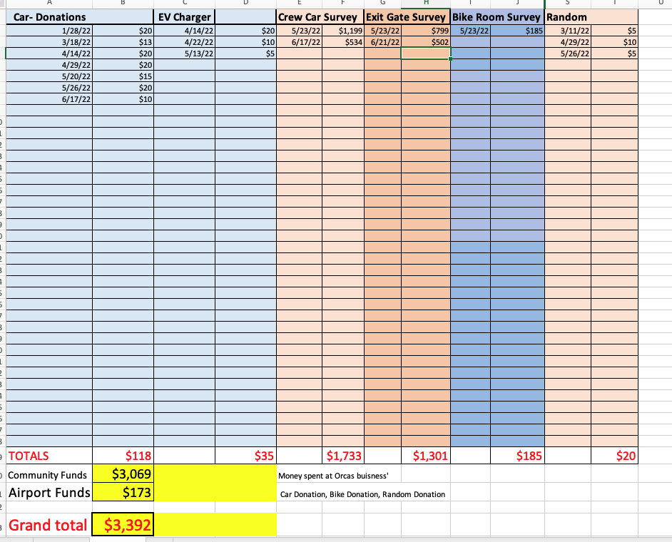

PAPI Project Schedule

Biplane Hangar Removal Project

